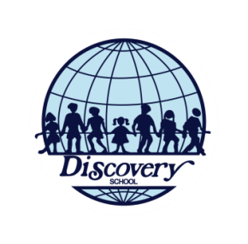
Discovery’s Referral Program
School Year 2018-2019

- Purpose: Is to provide a referral discount to families and staff for promoting Discovery School, encouraging the application for new admissions and help the DS community grow.

- Program Rules and responsibilities:
  - This referral program is open to all non-sponsored DS families and teachers. This referral program does not apply to area coordinators, administrative staff, alumni and maintenance staff.
  - It is the referring family’s responsibility to be sure that the Prospective Family mentions this program and the referring family’s name during their first contact with the admissions office. The Prospective Family will submit the referring family’s name on the application for admission. Referrals cannot be made retroactively.
  - There is no limit to the number of students that a DS family may refer.
  - This offer applies ONLY to NEW family applicants. Younger siblings of current or past DS families (returning families) do not qualify.
  - If more than one family refers a student (s), the referral incentive will be split evenly between each referring family.
  - The regular enrollment criteria must be met (Application and Evaluation Process).
  - The prospective student(s) must enroll and attend DS School to get the referral incentive.
  - The referral incentive is of $500 per student referred that enrolls in grades Kinder to Twelfth grade.
  - This referral incentive will be applied to the monthly tuition fee of a student, daughter or son of the referring DS family.
  - For teachers, restrictions apply. Ask the Head of School how to redeem your incentive.
  - The referral incentive will be given in a 3-month maximum period after enrollment.
  - Applications received after the second semester of school will be considered for a 50% of the $500 referral incentive.
  - The referral program will be reviewed every year.

